LEASE MANAGEMENT
College Name: SREE VENKATESHWARA ARTS AND SCIENCE COLLEGE,GOBI(CO-EDUCATION)
CollegeCode: brubd
TEAM ID: 116128410C28BEF85FF4AA5890D6C417
TEAM MEMBERS:
Team LeaderName: K.ROOBAN SANJAY
Email: roobansanjayk2023cs@gmail.com
Team Member1: S.BALARAMAN
Email: balaramans2023cs@gmail.com
Team Member: S.SOORAJ
Email: soorajs2023cs@gmail.com
Team Member: L.PARTHASARATHY
Email:parthasarathyl2023cs@gmail.com
1.INTRODUCTION
1.1ProjectOverview
TheLease ManagementSystem is aSalesforce-based application designed to streamline the processes associated with leasing real estate properties. It handles tenantmanagement, lease
contracts, payments, and communicationwith automation features such as flows, approval processes, and email alerts.
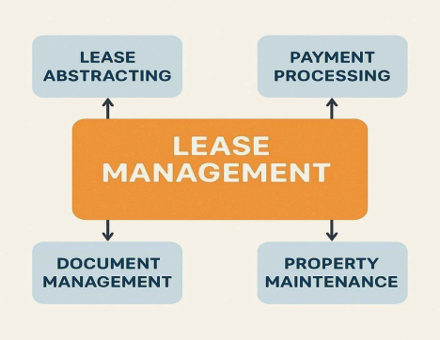
1.2 Purpose
Themain objective ofthe projectis to enable organizations to efficientlymanage properties, tenants, and lease-related activities. It reducesmanual intervention, improves accuracy, and ensures better compliance and communication.
DEVELOPMENT PHASE
CreatingDeveloperAccount:
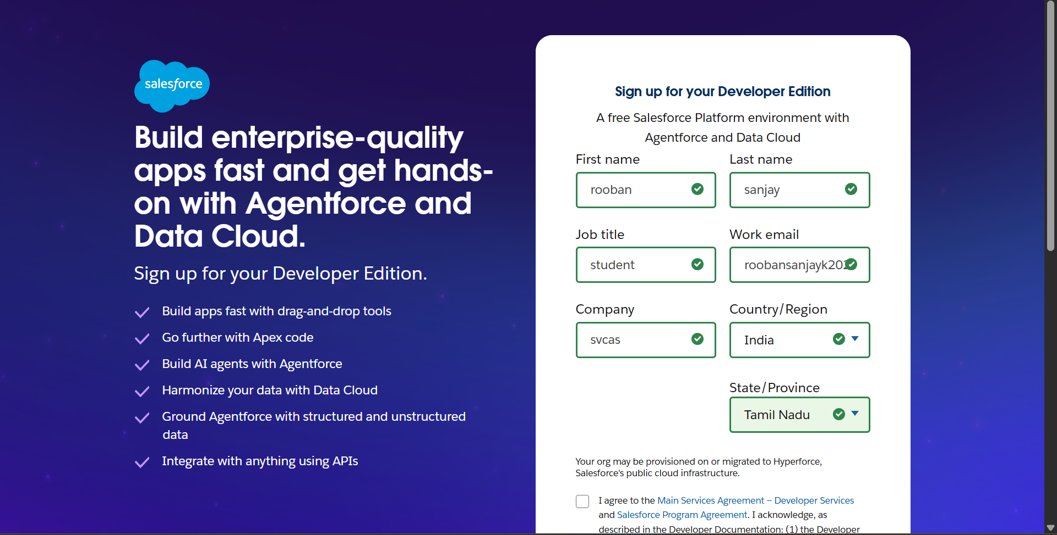
●Createdobjects: Property, Tenant, Lease, Payment
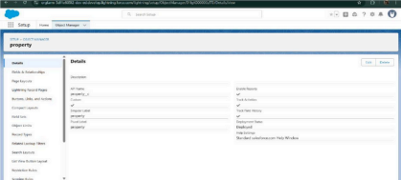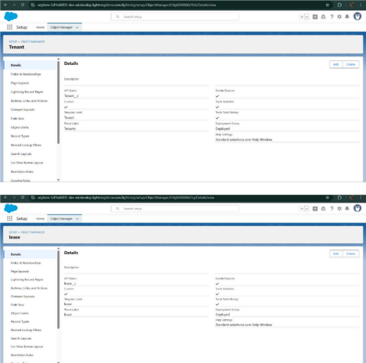
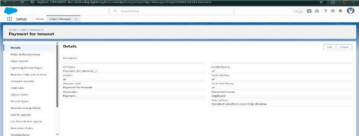
●Configuredfieldsandrelationships
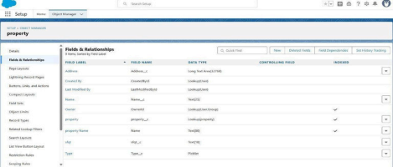
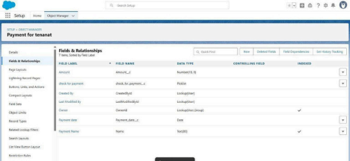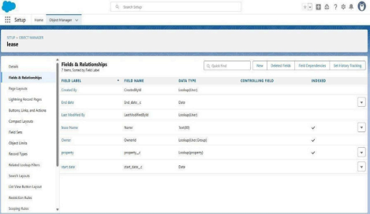
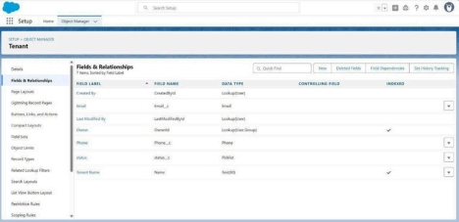
●DevelopedLightningAppwithrelevanttabs
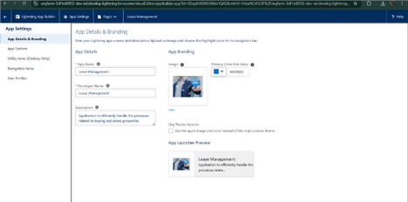
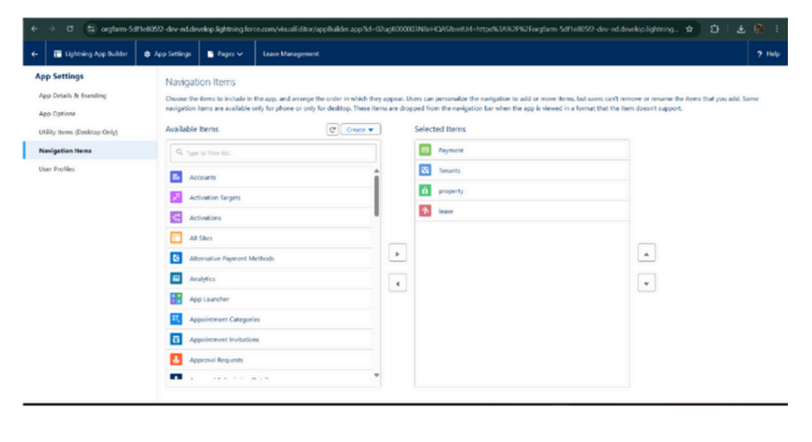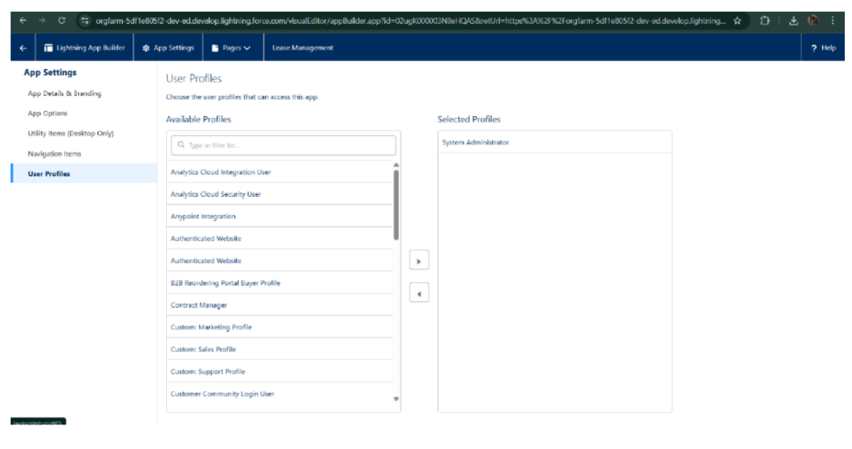
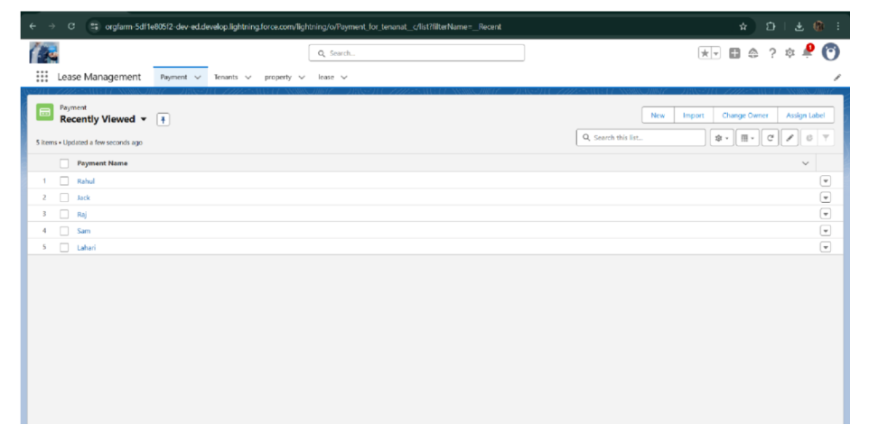
Implemented Flows formonthly rent and payment success●
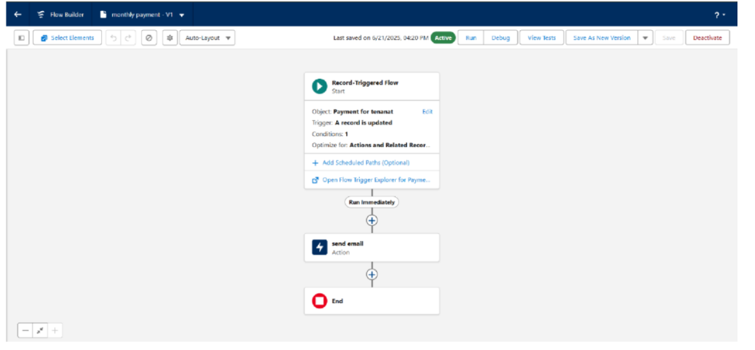● To create a validation rule to a LeaseObject
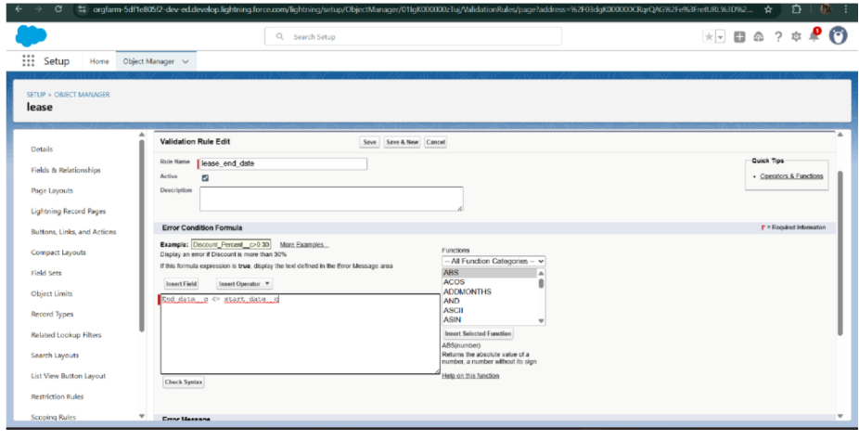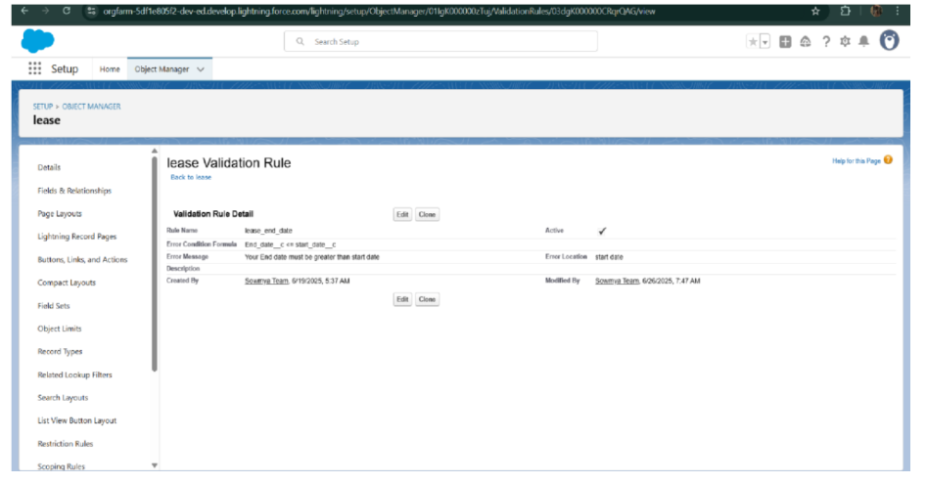●AddedApextriggertorestrictmultipletenantsperproperty
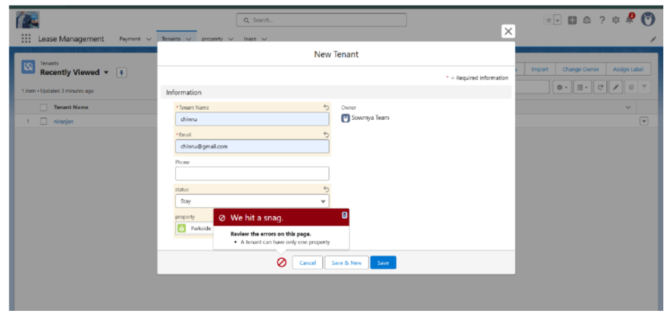
●Scheduledmonthlyreminderemails usingApexclass
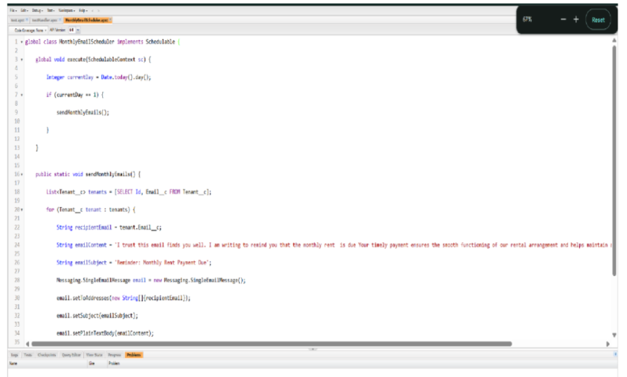
●Builtandtestedemailtemplatesfor leaverequest, approval, rejection, payment, and reminders
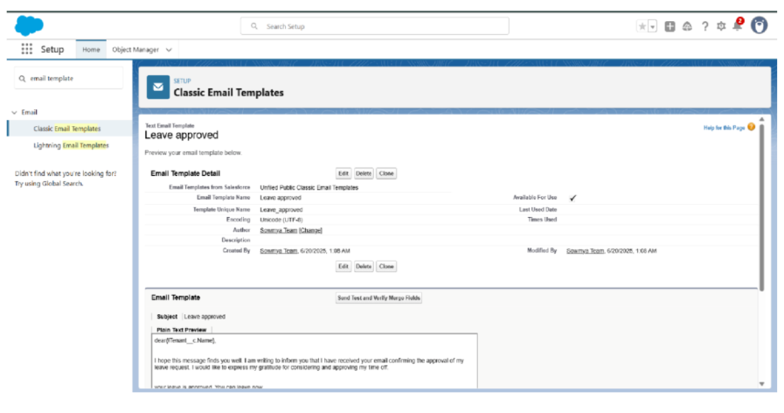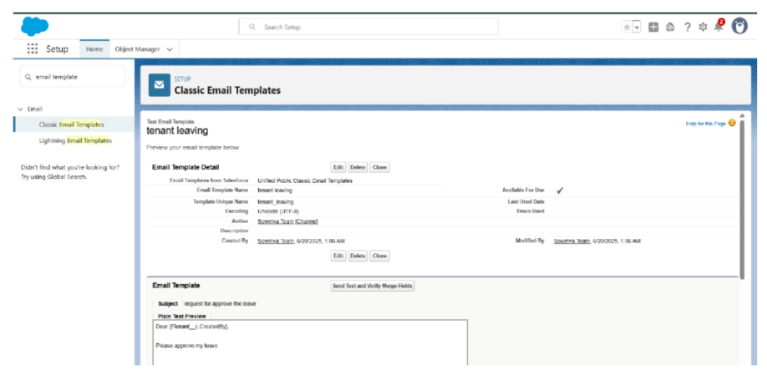
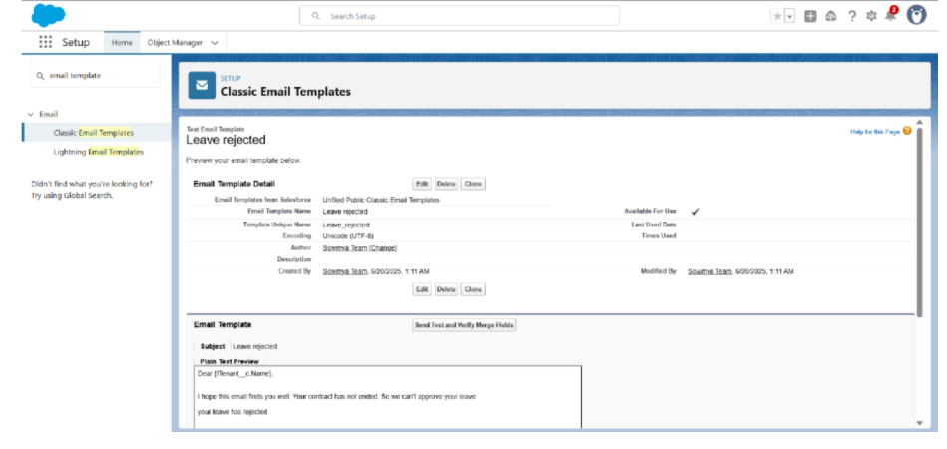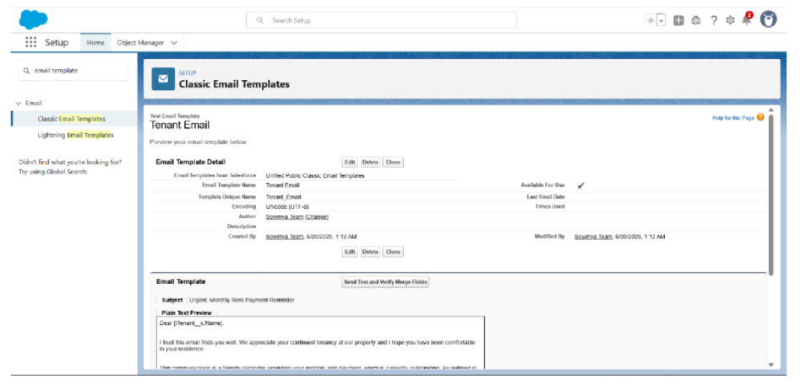
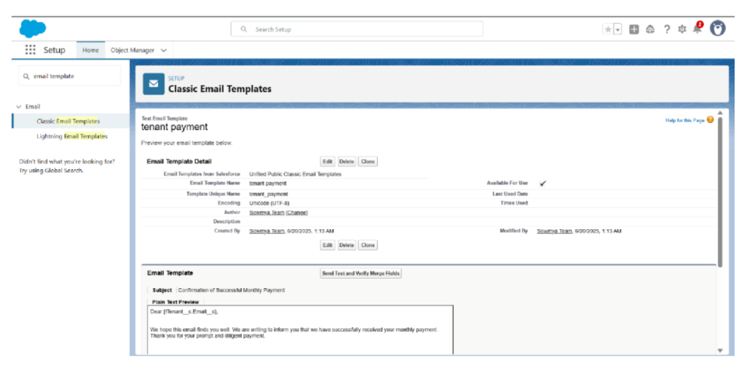
●
Approval Process creation For Tenant Leaving:
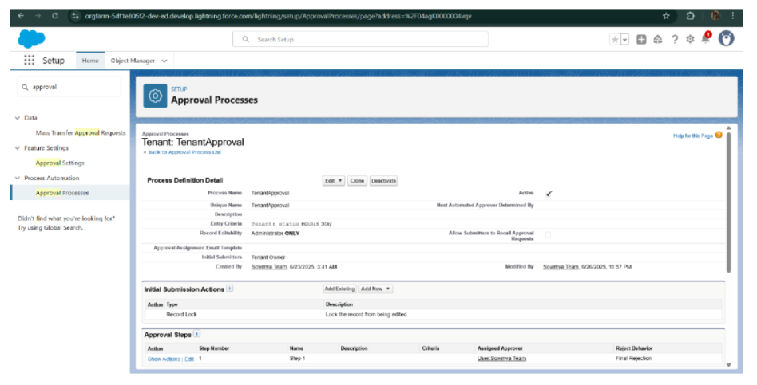ForCheck for Vacant:
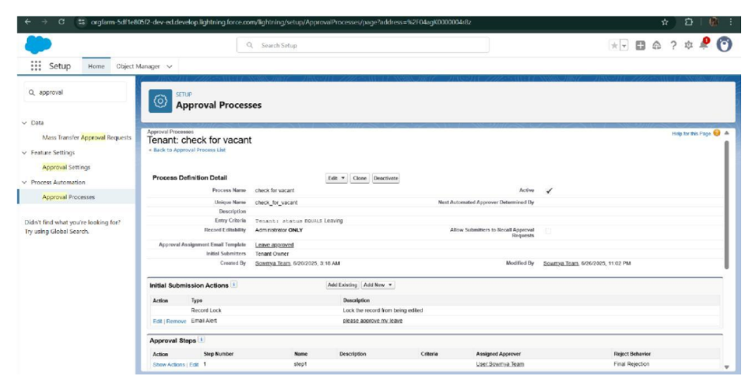
● Apex Trigger
Create anApex Trigger
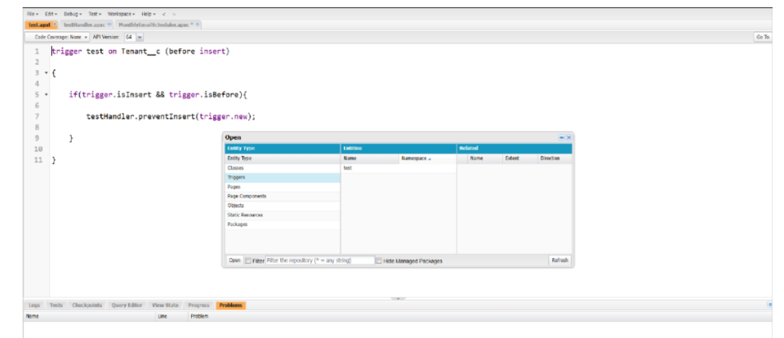
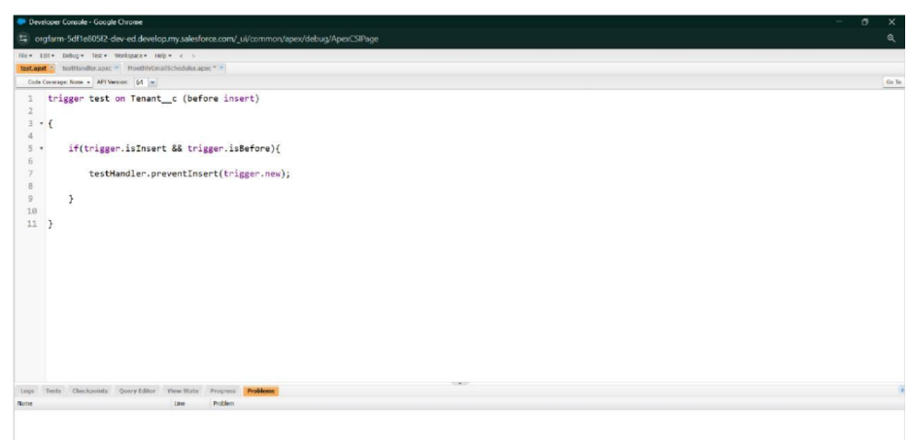Create anApex Handler class
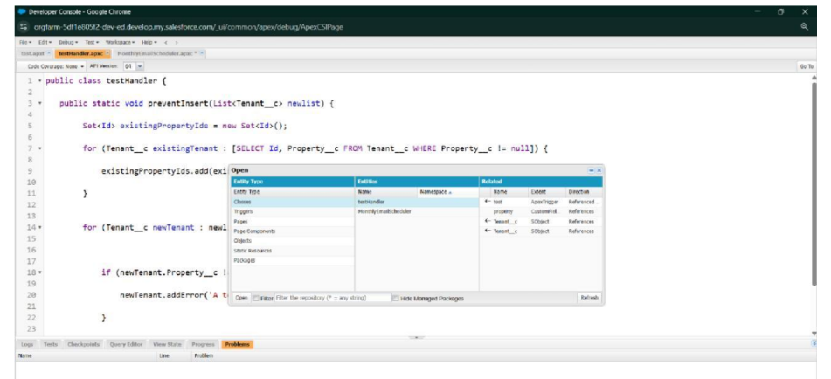
●FLOWS
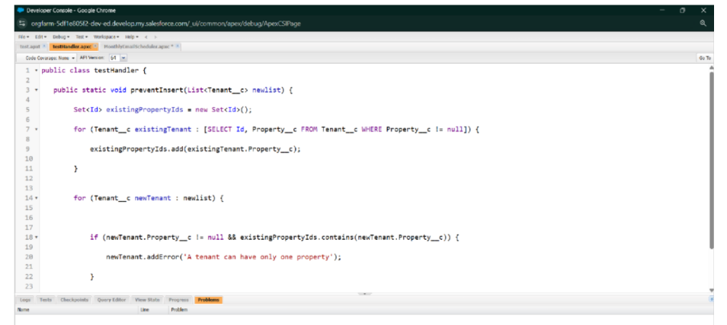
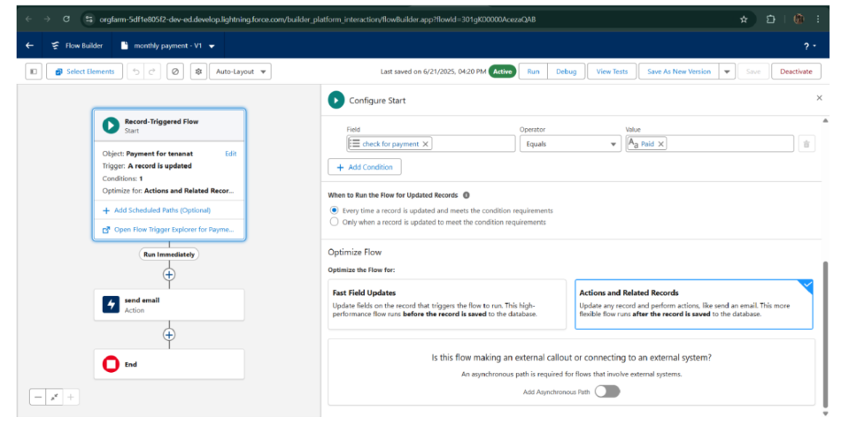
● Schedule class:
Create anApexClass
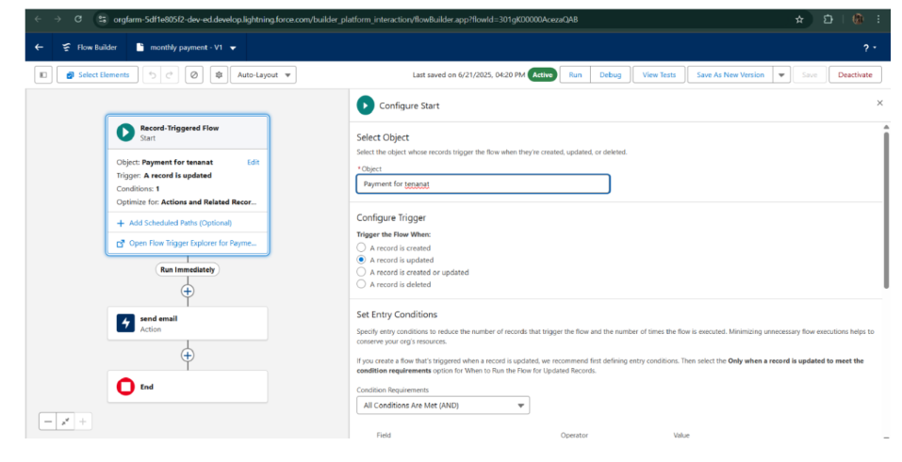
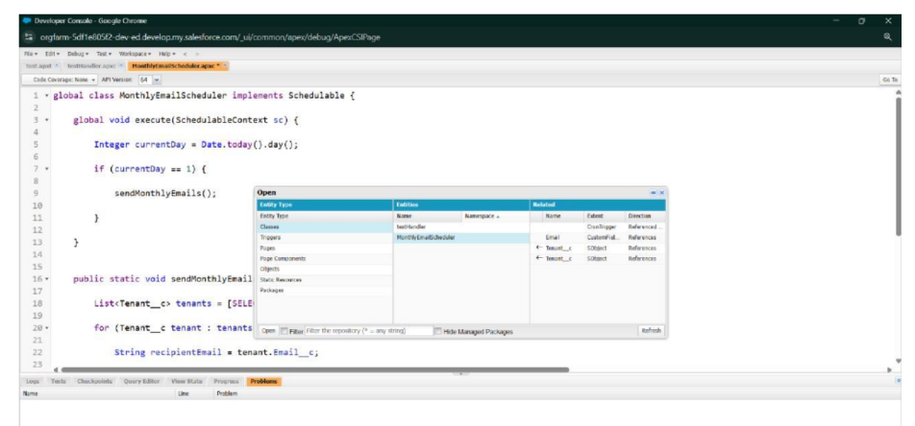ScheduleApex class
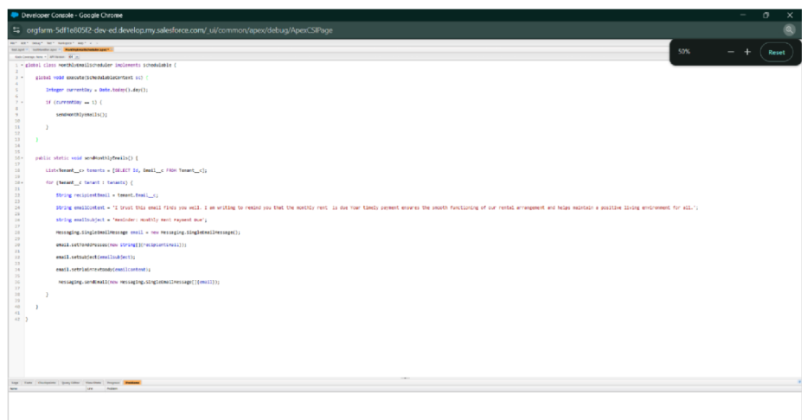
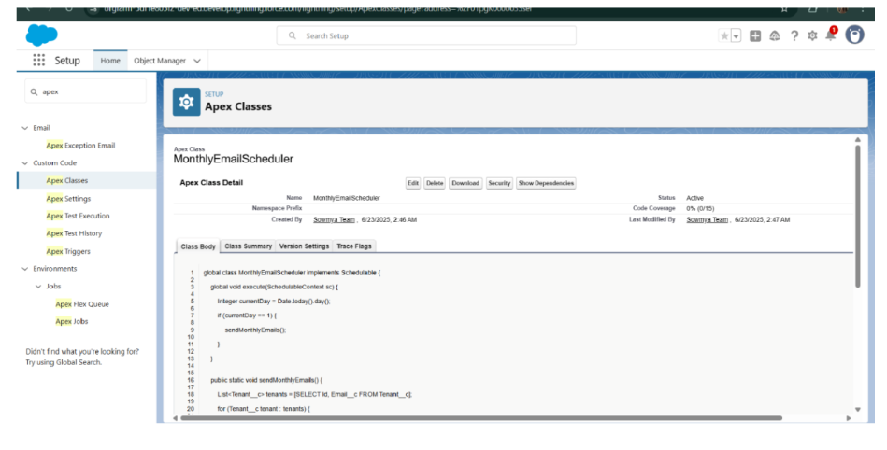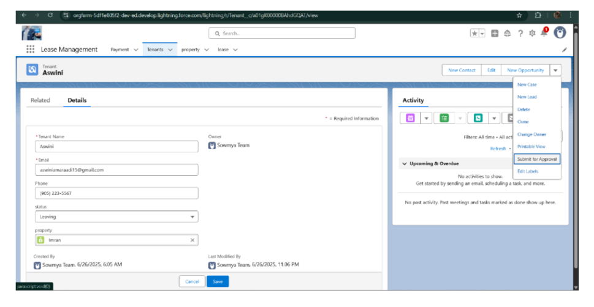
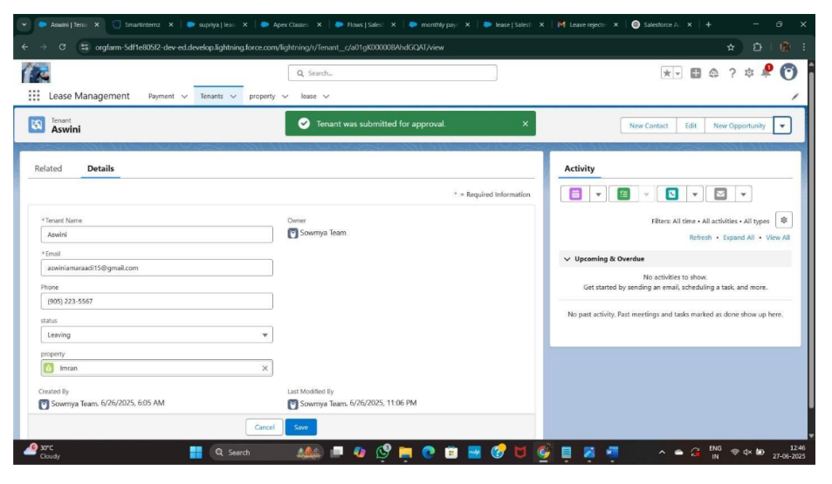
FUNCTIONALAND PERFORMANCE TESTING
Performance Testing
● Triggervalidationbyentering duplicate tenant-property records
●ValidationRulechecking
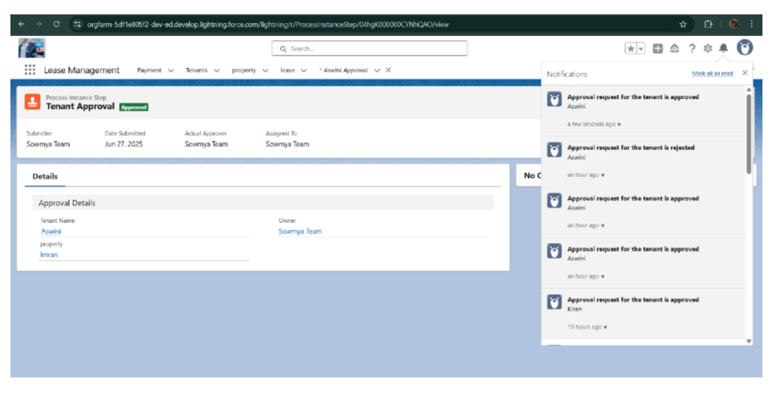
●Testflowsonpaymentupdate
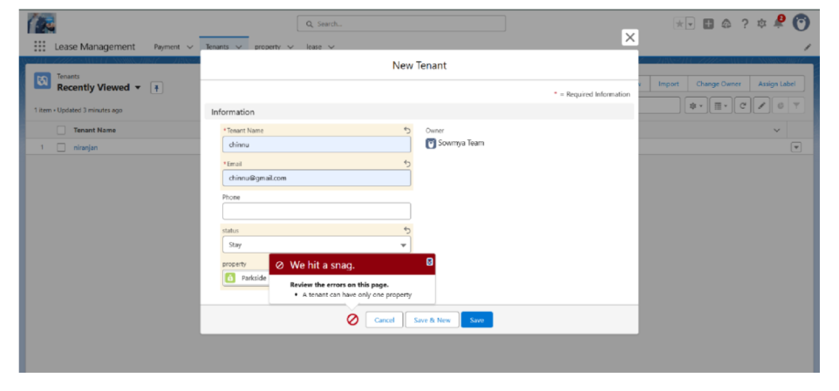
RESULTS
Output Screenshots
● Tabs for Property, Tenant, Lease, Payment
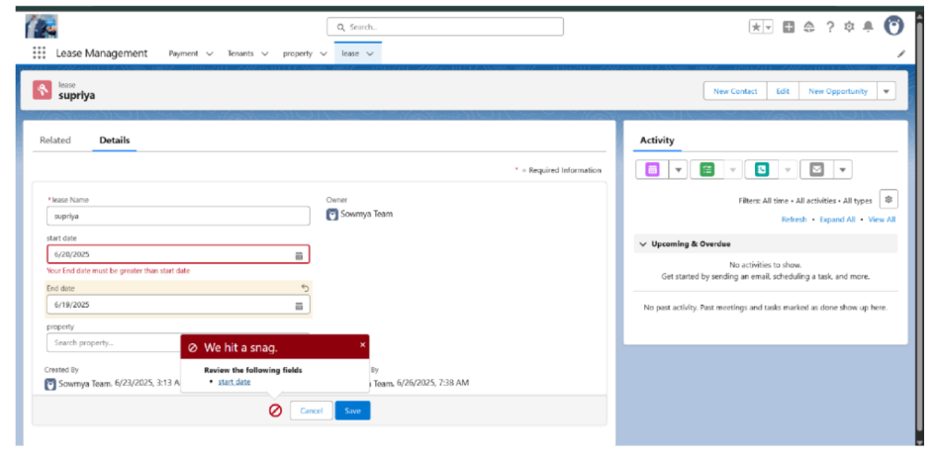
● Flowruns
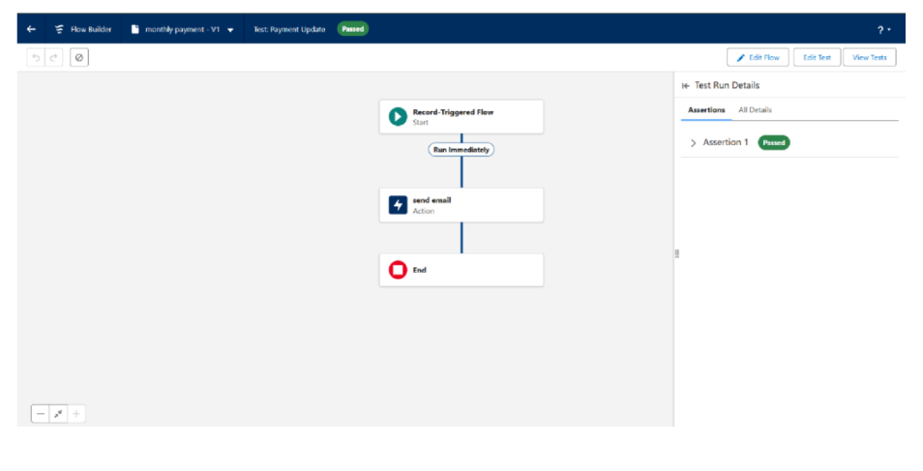Trigger errormessages ●
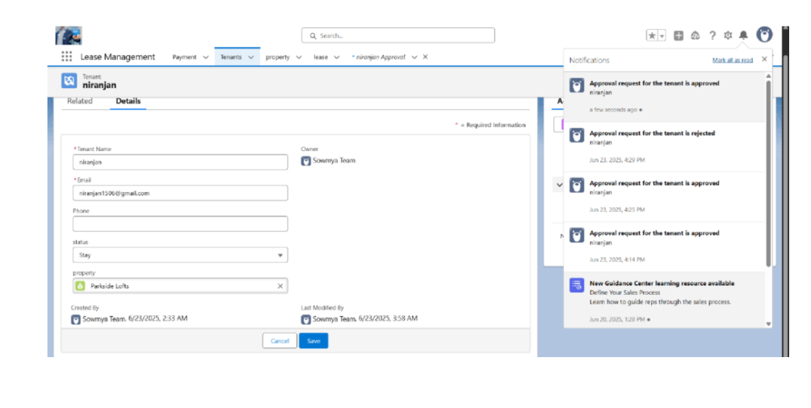
● Approval process notifications
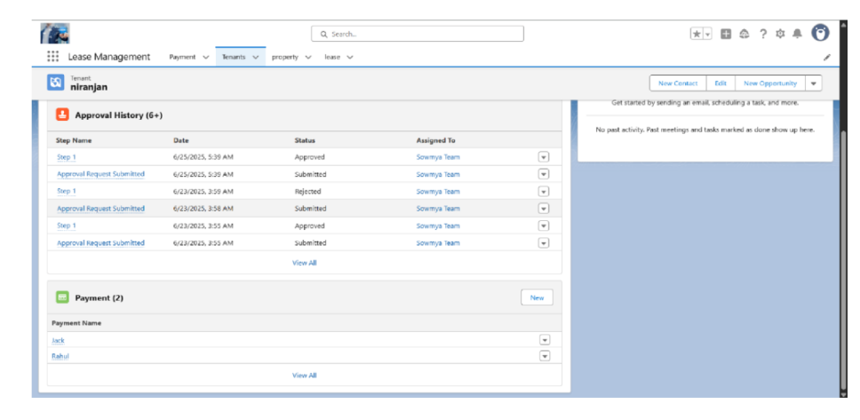
ADVANTAGES & DISADVANTAGES .
CONCLUSION
TheLease Management Systemsuccessfully streamlines the operations ofleasing through a structured, automatedSalesforce application. Itimproves efficiency, communication, and data accuracy for both admins and tenants.
APPENDIX
● SourceCode:
Provided inApexClasses and Triggers
Test.apxt:
trigger teston Tenant__c (before insert) { if
(trigger.isInsert && trigger.isBefore){
testHandler.preventInsert(trigger.new);
} }
testHandler.apxc:
public class
testHandler {
public static void
preventInsert(List
< Tenant__c>
newlist) Set<Id>
{
existingPropertyIds
= newSet<Id>()
for (Tenant__c existingTenant :[SELECT Id, Property__c FROM Tenant__c WHERE Property__c != null]) {
existingPropertyIds.add(existingTenant.Property__c;
} for (Tenant__c newTenant :
newlist) {
if(newTenant.Property__c != null &&
existingPropertyIds.contains(newTenant.Property__c)) { newTenant.addError('A tenant can have only one property');
}
}
}
}
MothlyEmailScheduler.apxc:
global class MonthlyEmailScheduler implements Schedulable {
global void execute(SchedulableContext sc) { Integer
currentDay = Date.today().day(); if(currentDay == 1) {
sendMonthlyEmails();
}
} public static void
sendMonthlyEmails() { List<Tenant__c>
tenants =[SELECT Id, Email__c FROM
Tenant__c]; for (Tenant__c tenant :
tenants) {
String recipientEmail = tenant.Email__c;
String emailContent = 'Itrustthis emailfinds youwell. I amwriting to remind you thatthemonthly rentis due Your timely payment ensures the smooth functioning of our rental arrangement and helpsmaintain a positive living environmentfor all.';
String emailSubject = 'Reminder: Monthly Rent Payment Due';
Messaging.SingleEmailMessage email = new
Messaging.SingleEmailMessage(); email.setToAddresses(new
String[]{recipientEmail}); email.setSubject(emailSubject);
email.setPlainTextBody(emailContent);
Messaging.sendEmail(new Messaging.SingleEmailMessage[]{email}); }
}
}

